
SOFTWARE TASK COMPETENCIES:

Automotive technology

MODULE B – Precision measurements

Duration of the task: 60 minutes.

Инструкция для конкурсанта

DESCRIPTION MODULE AND TASKS
In this module necessary make precision measurements of the cylinder -piston group M112 engine.
This requires dismantling the crankshaft, the first and sixth pistons. Make the necessary measurements and carry out installation according to technological requirements, observing the correct sequence. Make measurements in the checklist . Tightening torques should be adjusted to 50%
Please be very precise and specific in your requirements at appeal to To the expert.
TASKS
- Carry out the dismantling of the necessary parts in accordance with the technological requirements ;
- Take measurements of all cylinders.;
- Take measurements of the connecting rod and main journals of the crankshaft;
- Carry out installation according to technological requirements

INSTRUCTIONS FOR

PARTICIPANTS
After Togo How yours working place defined expert, announces task: “Precision measurements”, issues a task and gives time on studying. For acquaintance With technology security, ten minutes are allotted for the task, technological maps and workplace, and performance himself tasks competition 60 minutes.
For successful execution competitive tasks to you provided necessary tool, devices, equipment, which located on worker place.
The tool should be used strictly for its intended purpose, use mainly cap keys And heads, pick up their strictly By size.
The expert has the right to terminate the work you are performing early in case when you grossly violate the work technology and technique security at this leave behind you previously dialed points.
Complete the above tasks. If you complete these tasks ahead of time or you will not be able to continue the work, pass this document to his to the expert And come back V room For contestants, to wait next stage of the competition.

SAFETY
You are allowed to work if you have the following: facilities individual protection:
workwear;
If at you long hair, That necessary head dress for Togo to They didn't hang down.
U you Not must be:
jewelry products (rings, bracelets, watch, necklaces, pins);
ties;
hanging cords And others items.
Before you start working, you should discuss with your expert dangerous production factors, which can on you influence.
You must perform work in compliance with technical requirements security.
You Not you'll lose points behind That, What asked questions to his to the expert related With yours security.
You must fully understand All, What written V this document, before begin work.
You you'll lose points, If you will violate requirements technology security in lead time work.

FACILITIES INDIVIDUAL PROTECTION
You must have:
•Shoes With hard sock
•Specialist. clothes.
•Cotton gloves.
•Latex gloves For work With aggressive liquids.
Head attire

Full name competitor_________________________________

Crankshaft measurement
Table No. 1
Measurement procedure diagram | Neck | A A 1 | A B 1 |  | _{A1 A1} | _{A1B1}
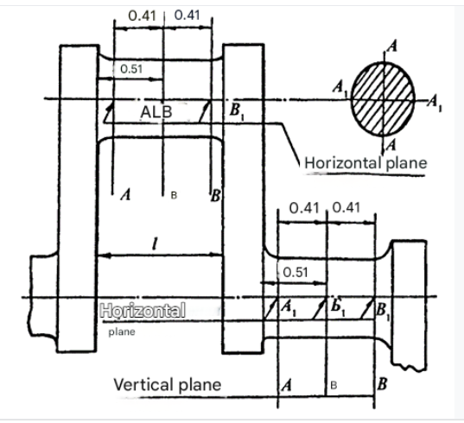 | Root 1
 | Root 2
 | Root 3
 | Root 4
 | Connecting rod 1
 | Connecting rod 2
 | Connecting rod 3
 | Connecting rod 4
 | Connecting rod 5
 | Connecting rod 6

Measuring cylinder liners.
Table No. 2

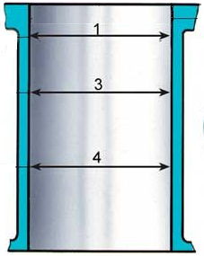
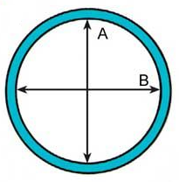

1 Cylinder
Level | Plane A | Plane B
Level 1 TDC
Level 2 Middle Part
Level 3

2 Cylinder
Level | Plane A | Plane B
Level 1 TDC
Level 2 Middle Part
Level 3

3 Cylinder
Level | Plane A | Plane B
Level 1 TDC
Level 2 Middle Part
Level 3

4 Cylinder
Level | Plane A | Plane B
Level 1 TDC
Level 2 Middle Part
Level 3

5 Cylinder
Level | Plane A | Plane B
Level 1 TDC
Level 2 Middle Part
Level 3

6 Cylinder
Level | Plane A | Plane B
Level 1 TDC
Level 2 Middle Part
Level 3

